we have created two programs as following:
debug1.c: using malloc() but forgets to free it before exiting.

debug2.c: print the value of a integer from an array allocated with malloc() after free().

In debug1.c, we can find noting with gdb. But with the help of Valgrind, we can find the memory leak that this piece of memory is still accessible in the heap. it’s still been consumed.
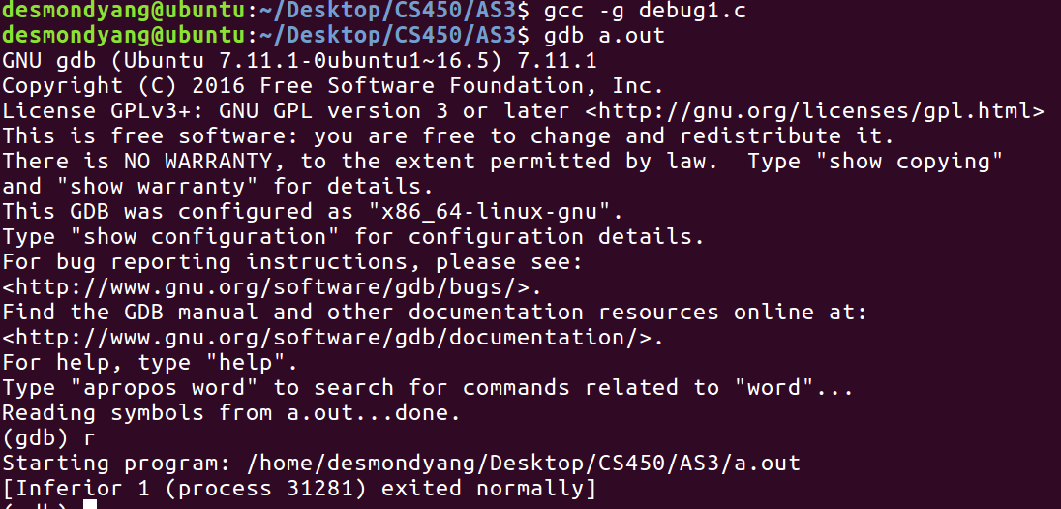
GDB Result
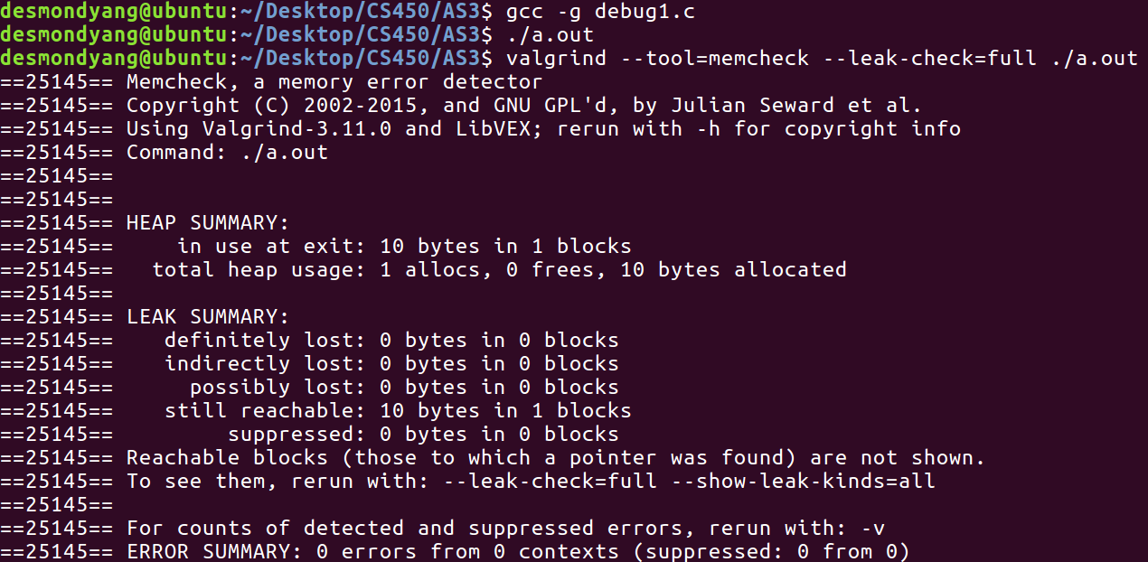
Valgrind Result

In debug2.c, we can find noting with gdb. But with the help of Valgrind, we can find that program tries to access a memory space which is freed in the heap.
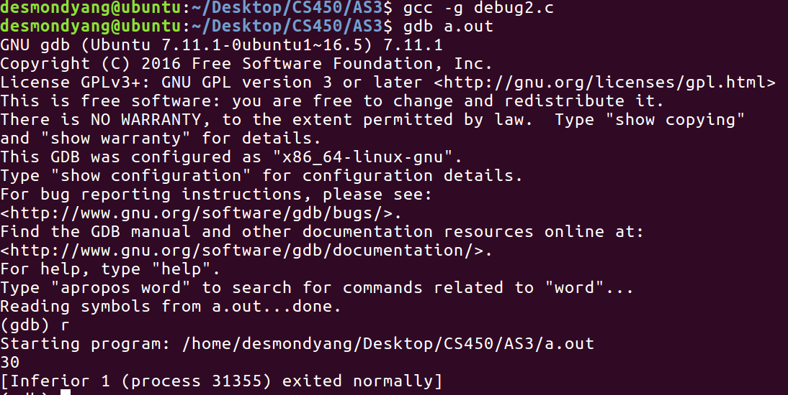
GDB Result
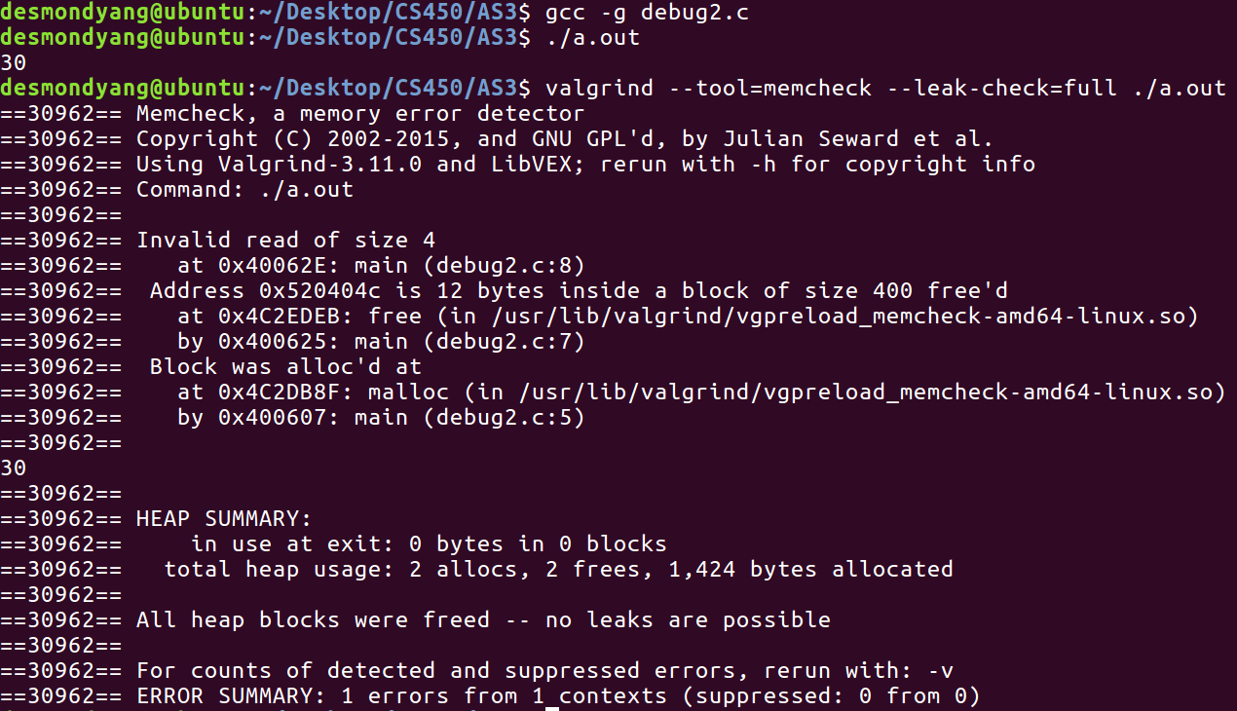
Valgrind Result

